**Ba Dung Nguyen**

**Max How Li**

**Project: Clapping Switch**

**Block diagram + Graphs**



Fig. Block Diagram.

Input sound

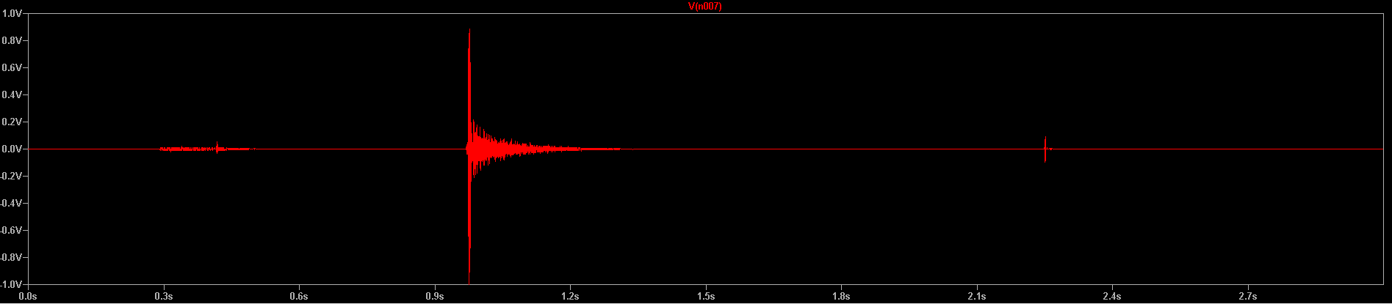

Sound filter

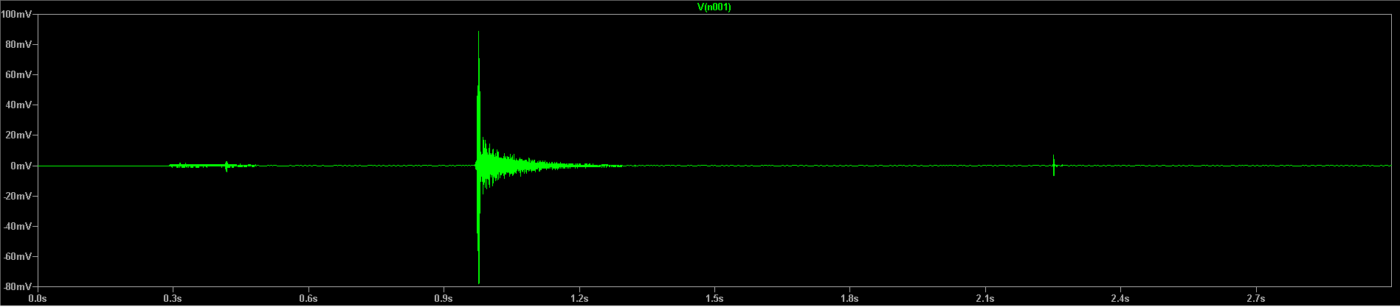

Amplifier

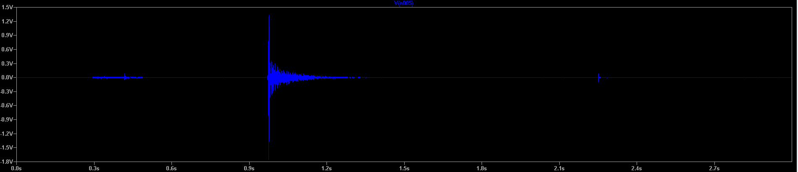

Switch, delay and amplify switch/delay signal for LED

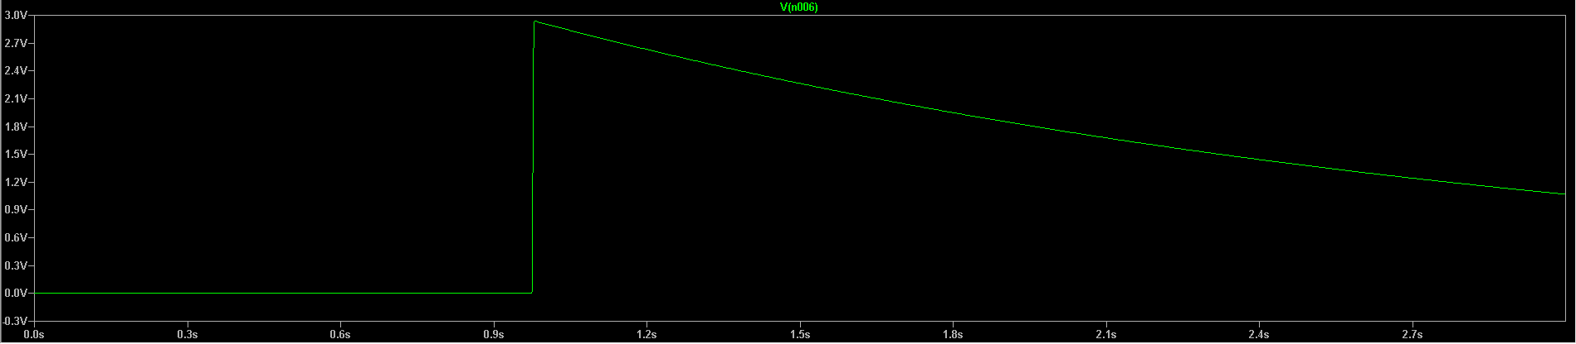

Voltage across LED

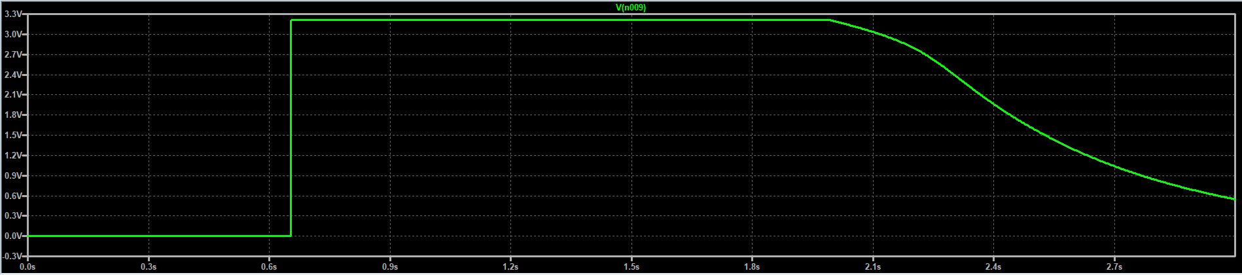

**Project component list (May change)**

|  |  |  |
| --- | --- | --- |
| **Component** | **Number** | **Values/Model** |
| Voltage source | 1  1 | +/-9V DC (+/- ground config)  Mic input |
| Resistors | 1  2  1  1  1  1  1 | 30  50  330  500  1k  2k  10k |
| Capacitors | 1  1 | 0.1u  47u |
| Op amps | 3 | LT1097 |
| Transistors | 1 | N3904 |
| LEDs | 1 | NSPW500BS |

**Datasheets**

LT1097 Amplifier:

<https://www.analog.com/media/en/technical-documentation/data-sheets/1097fas.pdf>

2N3904 Transistor:

<https://www.onsemi.com/pub/Collateral/2N3903-D.PDF>

Electret Condenser Microphone:

<https://www.cuidevices.com/product/resource/cma-4544pf-w.pdf>

LED:

<http://search.alkon.net/cgi-bin/pdf.pl?pdfname=15190.pdf>